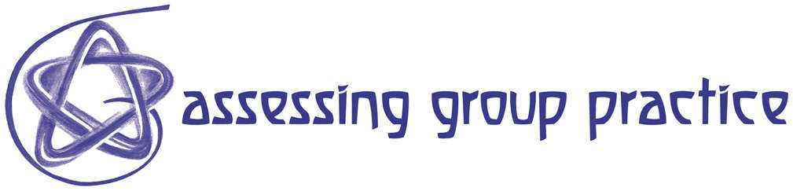

R12 How to Think Creatively Using De Bono's Six Hats Method

If your group gets bogged down in the storming stage, where discussions seem to become circular or where new ideas are scarce and arguments begin to dominate the proceedings, applying De Bono's Six Hat method creatively can move the group from storming into the norming and performing stages.

De Bono originally devised his six metaphorical hats, each of a different colour, to represents a particular mode of thinking thus:

White hat information (think of white paper, neutral)
Red hat feelings, emotions, intuition and hunches (think of red fire, warmth and feelings)
Black hat caution, risk assessment & criticism (think of a judge's black robes)
Yellow hat logical positive (think of sunshine and optimism)
Green hat creative effort, possibility (think of green vegetation and growing, leaves etc.)
Blue hat overview, thinking about thinking and managing the thinking process (think of blue sky)

The six hat method, originally intended to develop parallel thinking, can be highly effective when used in a variety of different ways to develop an awareness of group dynamics.

The group agrees to use a particular coloured hat, for example, when the white hat is in use, everyone in the group focuses, in parallel, on laying out the information. At no point is there any attempt to disagree, to challenge or to dispute a point. Everyone is thus focused in the same 'direction' and is thinking co-operatively, in parallel.

Once all the information is laid out, the group might decide that it is time to use the green hat and to all be as creative as possible, again not censoring any ideas at this stage, but simply laying them alongside each other.

The hats may be usefully employed when one or more group member is 'being difficult' in some way or other and impeding the progress of the group. For example, if someone is being really negative, instead of being confrontational and saying: "stop being so negative" or "you're such a wet blanket, you always point out the reasons why we can't do something!" you can simply ask if s/he could now change from the black hat and put on her/his yellow or green hat. This objectifies the situation and avoids potentially confrontational situations. Being cautious and assessing the risk is an important role within a group, but if someone wears the black hat for too long, the group can begin to resent it.

Group Activity

The following activity requires some group members to observe the rest of the group and to provide them with feedback after the task. Observers should use the Observation and feedback sheet (R19) and the Guide for Giving and Receiving Effective Feedback (R18)

Planning and setting up a fund raising performance.

This committee has been formed to organise a fund-raising performance. Your group has 20 minutes to put together a draft plan which will outline how you intend to achieve this. Try to incorporate De Bono's six hat method in your planning.

Make sure that you utilise the skills of all the members of your team.

You will need to decide:

How you make best use of the limited time
How you organise yourselves
Who takes on which role(s)
How you will use De Bono'd six hats method

To get you started, here are some key issues to include in your draft plan:

- Research for suitable venue and date of event
- Market research of potential audience
- Type of performance / event in relation to
- Purpose and objectives of the event
- Budget in relation to profit margin etc.
- Whether you need a loan to get started initially
- Performers (professional or amateur?)
- Advertising
- Staffing of the event

After 20 minutes, the observers should provide the group with constructive feedback (based on guidance in R18 and R19) commenting particularly on the methods used to achieve the task and where these were successful or less appropriately applied.

References
De Bono, E. (1994) Parallel Thinking: From Socratic to de Bono Thinking, Penguin Books

